GIT AND GITHUB - 1
1.Check Git Version
git –version
2. List Files in Directory
Ls
3.Check Git Status (Before Initialization)
git status
4. Initialize Git Repository
git init
5. Check Files Again (Hidden Files)
ls -a
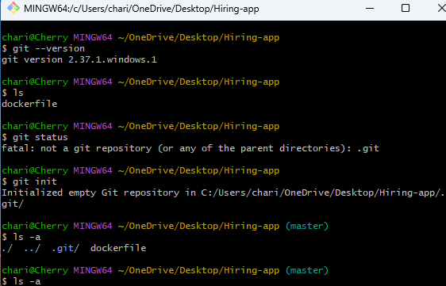

6.Going inside the Git internal folder
cd .git/
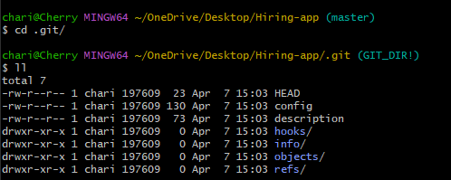
The repository is initialized, and Git shows the dockerfile as an untracked file that needs to be added and committed to track changes.
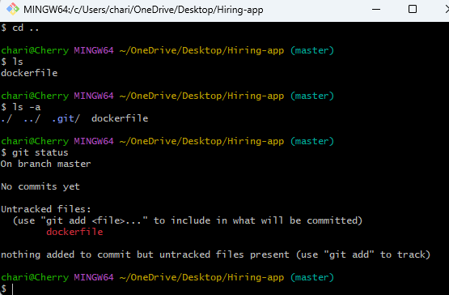
7.deletes the entire .git folder
rm -rf .git/
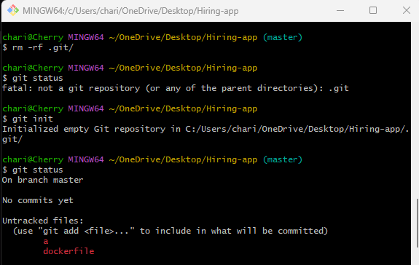
8.Set Username
git config --global user.name "Charitha_royal"
9.set useremail
git config --global user.email "charitharoyalrcr@gmail.com"
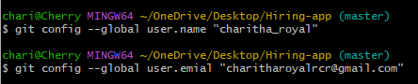
10.View Git Configuration
git config --list
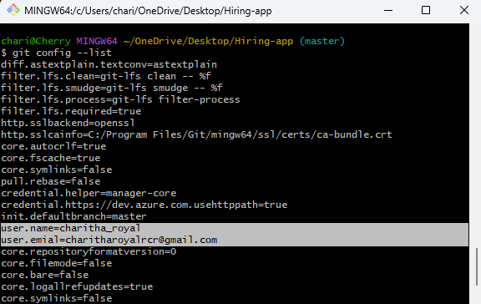
11.create a empty file – files will not add to tracking without using add command
touch
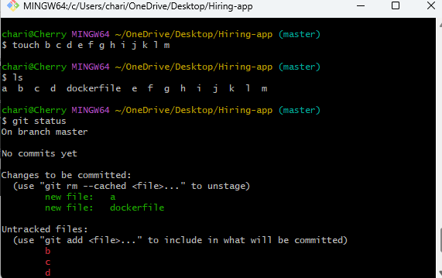
12. adding files to tracking
git add a dockerfile
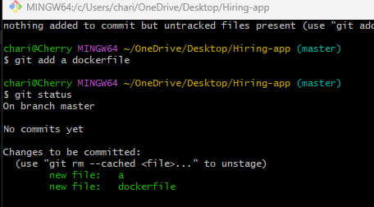
13. to add or move all the files to tracking area we use .
git add .
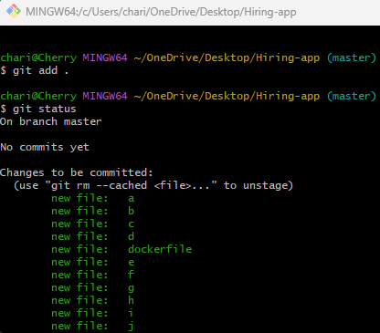
14. to commit files we use
git commit -m “added couple of files”
Then if we see status then files are commited
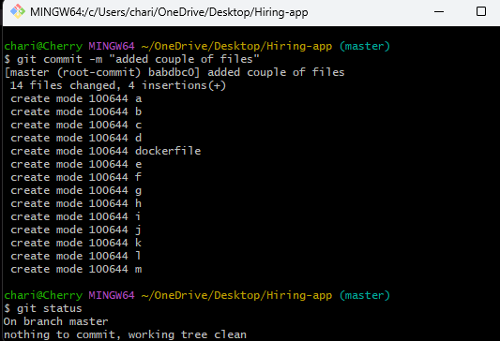
15. It prints all the logs means whatever changes you have did to your work directory everthing stored.
git log
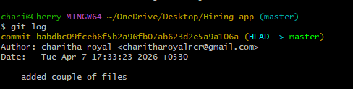
16. Shows all connected remote repositories with their URLs.
git remote -v
17. Adds (connects) your local project to a remote GitHub repository.
git remote add original
https://github.com/Charitharoyal/techie-horizon-19.git
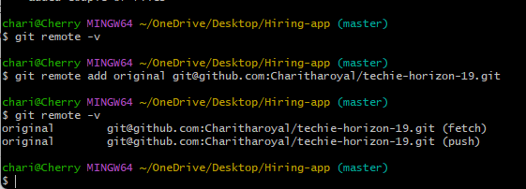
18. this command will understand which brach
git push -u origin master
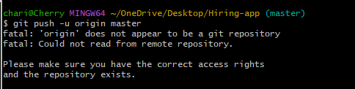
19. to generate keypair
ssh-keypair
then paste that pubic key and view that with cat command and we get ssh and go to github and paste under ssh key then it will create ssh keys successfully.
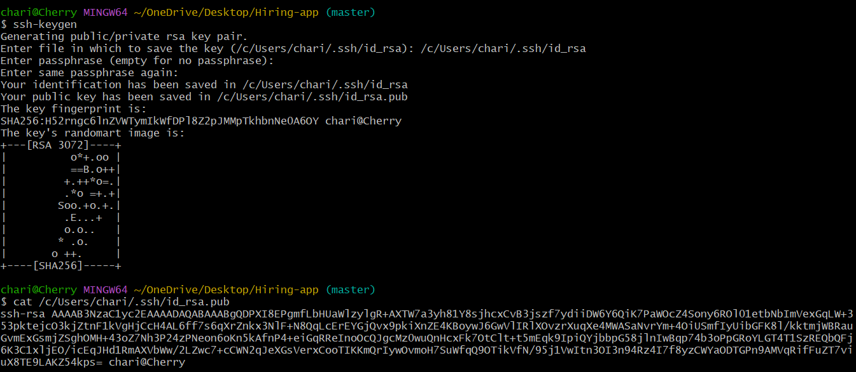
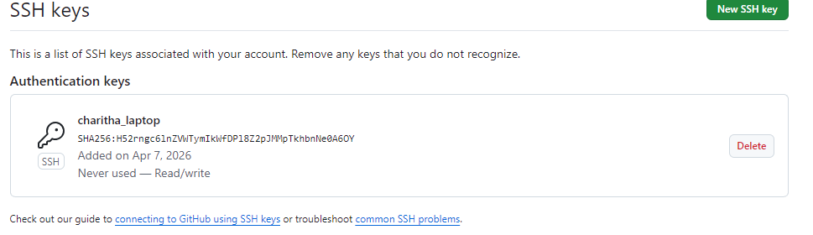
20. to push the files to github
Git push -u origin master
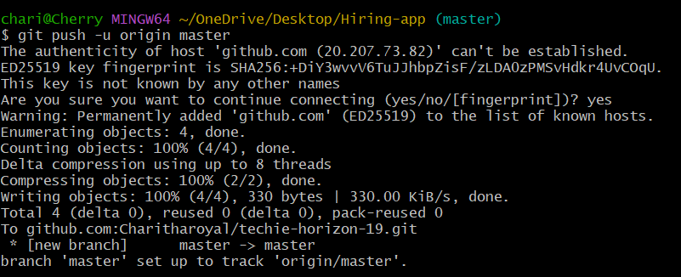
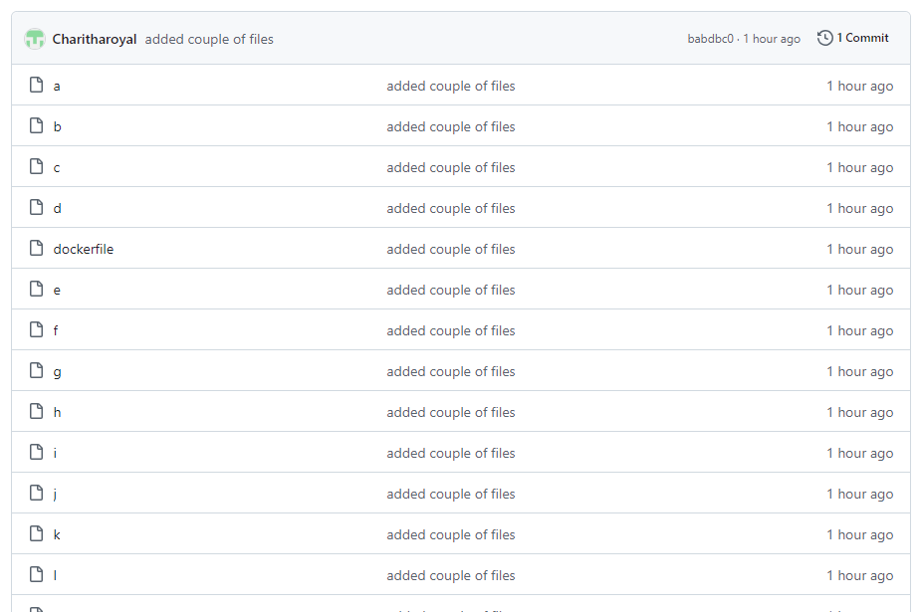
21. When we use the rm command, the Dockerfile is deleted only in the local repository and not in GitHub because both local and remote repositories maintain separate copies. To reflect this deletion in GitHub, we need to follow Git steps: first check the changes using git status, then stage the changes using git add . commit them using git commit -m "Deleted Dockerfile", and finally push the changes using git push -u origin master. After pushing, the file will also be deleted from the GitHub repository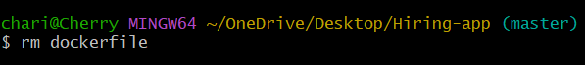

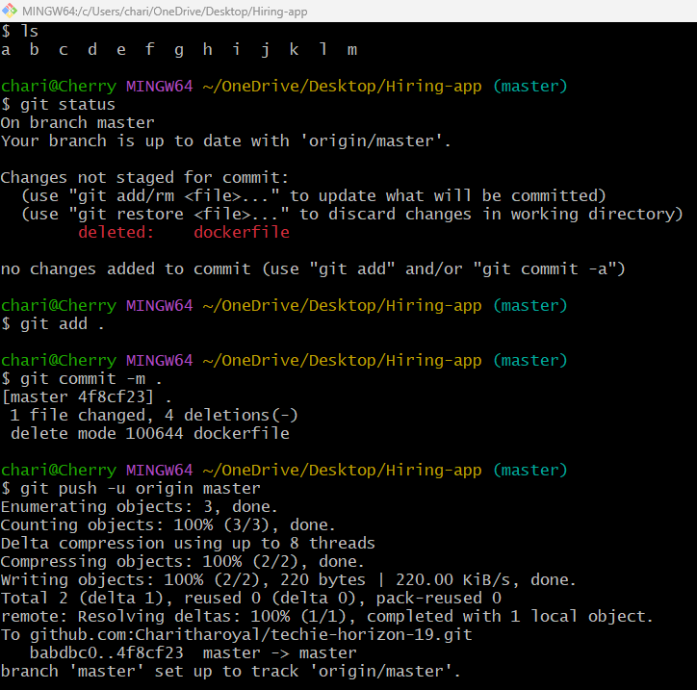

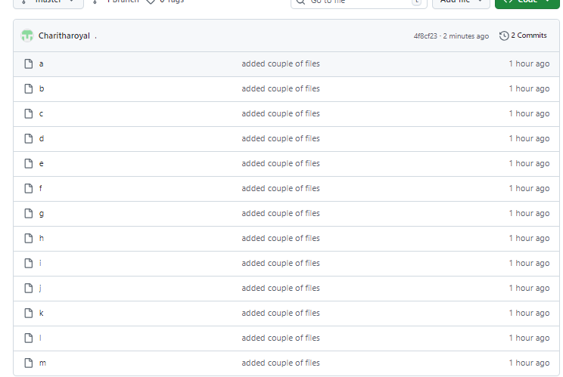
I am trying to push a file to central repository
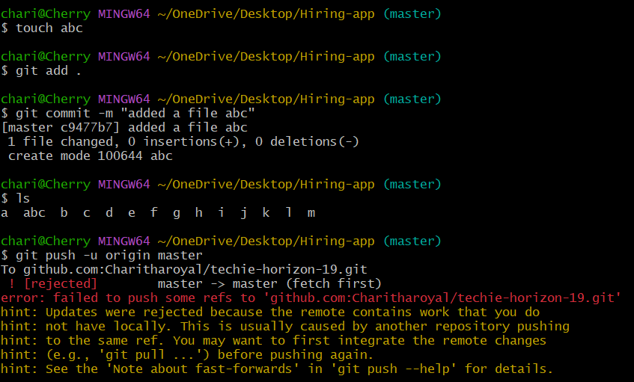
22. to get from central repo to locl repo
Only pull the updated changes
git pull
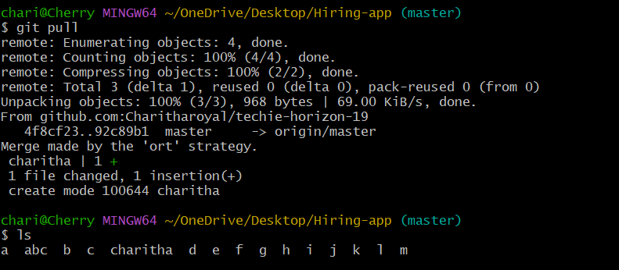
Again we push and we can see all files
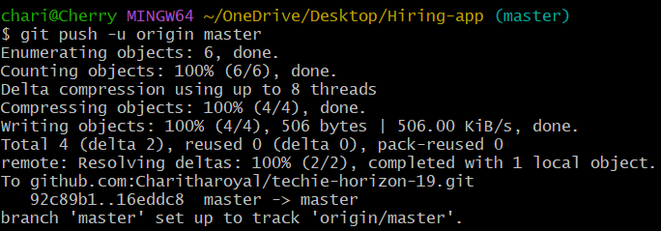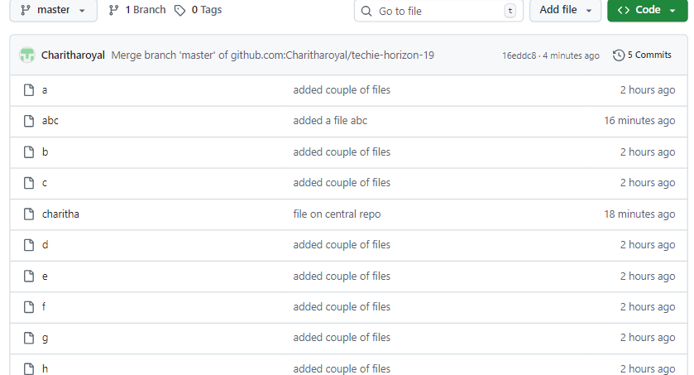
23. used to download complete project
git clone

